Ideation Phase
Brainstorm & Idea Prioritization Template

Date | 17 June 2026
Team ID
Project Name | ShopEZ
Maximum Marks | 4 Marks

Brainstorm & Idea Prioritization :
Brainstorming creates an open environment where every team member contributes ideas. Volume is valued over polish, all ideas are welcome, and the team then groups and prioritises them. The output below shapes the ShopEZ feature set.
Step-1: Team Gathering, Collaboration and Select the Problem Statement
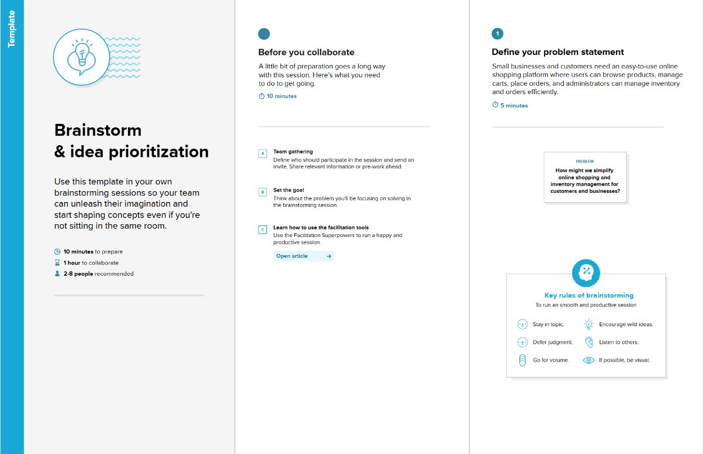

step-2: Brainstorm, Idea Listing and Grouping
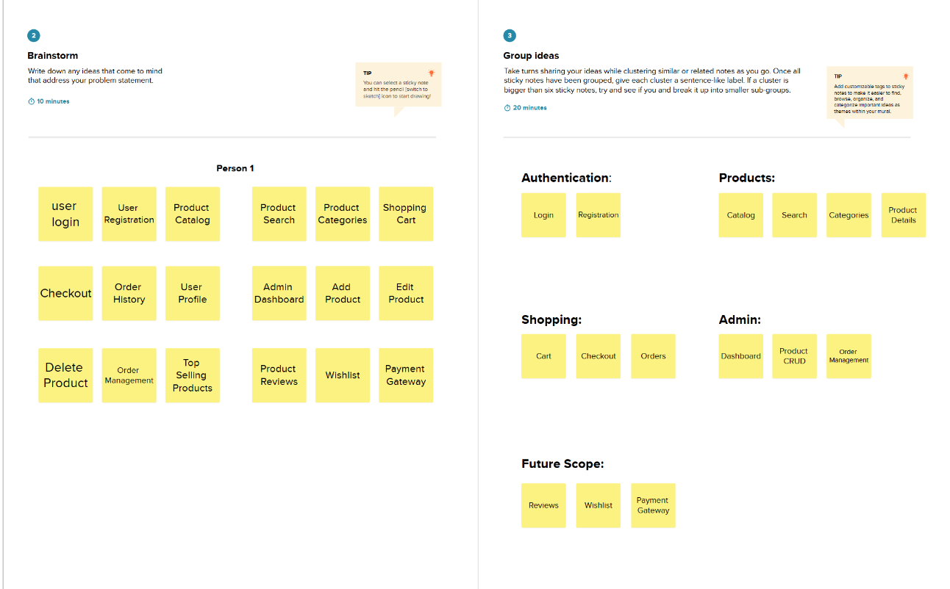

Step-3: Idea Prioritization
